Distributed battery optimization to minimize cumulative aging

Team members: Raja Selvakumar, Yaser Marafee, Yu-Hsin Huang

# Introduction

## Motivation & Background

Electrification of renewable energy integration and transportation of automobile compose two essential pathways towards the reduction of greenhouse gas emission and therefore the impact of global warming.1 On the other hand, the importance of energy storage devices can be manifested as the widely usage in consumer electronics, electric vehicles, and grid storage. However, batteries show aging, namely performance losses, during their lifetime due to the decrease in capacity, which leads to voltage decay and loss of power. The understanding of durability of batteries incurs challenges because the aging mechanisms which result from various processes in diverse time scales are challenging to thoroughly conceptualize and provide robust optimization models accounting it. Take the aging mechanisms of lithium ion battery in EV applications for example. As Figure 1 demonstrates2, there are a host of potential reasons for Li-ion aging. Current research has only been able to study capacity fade in smaller systems, and that too limited to physical mathematical models without experimental insight.

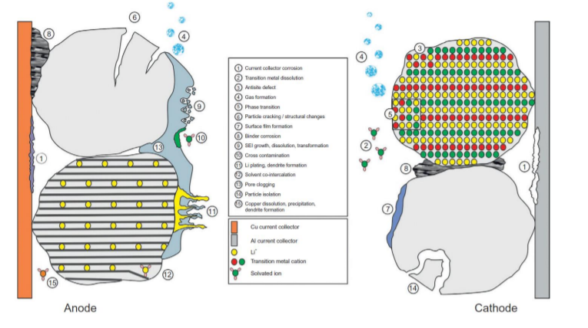

**Figure 1.** Lithium ion battery aging mechanisms in EV applications. Storage and operating conditions both combine for numerous effects on battery aging.

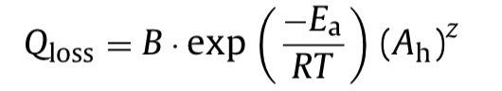This project focuses on development of an optimization model which incorporates the grid storage and cells aging mechanisms. We try to investigate the capacity fade from parameters such as time, temperature, depth of discharge (DOD), and discharge rate based on the following equation.3

(1)

In Eq. (1), Qloss is the percentage of capacity loss, B is the pre-exponential factor, Ea is the activation energy in J mol−1, R is the gas constant, T is the absolute temperature, and Ah is the Ah-throughput, which is expressed as Ah = (cycle number) × (DOD) × (full cell capacity), and z is the power law factor.

Our group consists of three chemical engineering master’s students in the Product Development Program. We have all taken classes in electrochemical systems, ranging from mathematical fundamentals to first steps of solid-electrolyte interphase (SEI) modelling. These experiences provide us an advantage to test the differences between black-box and white-box modelling approaches. There are some ambitious challenges to address when attempting to model material degradation in these batteries from physical intuition, while also converting it to a control problem with fast response time. As a team, our goal is to learn advanced control and machine learning techniques, so we hope to show this in our project results. We recognize that better autonomous battery monitoring is a pressing challenge and would like to embark on the challenge.

## Relevant Literature

## (i)

## From Figure 2A, cycling gradually damages the configuration of electrodes and therefore hinder the performance of the batteries, especially at high DOD. As for the influence of temperature shown in Figure 2B, the degradation increases as the increase of temperature.1 Researches have put emphasis on developing models to account the mechanisms.

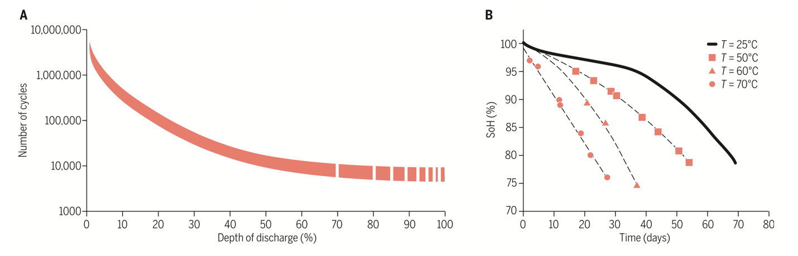

**Figure 2. Influence of DoD and temperature on battery performance degradation**. (A) Cycle life as a function of DOD for Li-ion cells operating at 25°C. (B) State of Health (SOH) as a function of time for Li-ion cells cycling at a rate of 1C at different temperatures.

(ii)

Battery aging can be classified into two main categories. One is the calendar aging and the other is the cycle one.4 The calendar aging is associated with the phenomena and the consequences of battery storage. On the other hand, cycle aging corresponds to the influence of utilization periods of batteries.

Calendar aging is the irreversible process of lost capacity during storage. The battery is degraded due to itself energy storage. The main factor of calendar aging attributes to temperature. When the temperature of storage increases, side reactions in the cells are facilitated and therefore induce the capacity fade. The other principal variable under investigation in calendar aging is Stage of Charge (SOC). A higher battery degradation results from the elevated SOC.5

Cycle aging attributes to either charging or discharging of the battery. Many factors are involved with this kind of aging, including the abovementioned factors in calendar aging, because the mechanisms of aging happen whether the battery is under usage or not. Factor of charging/discharging voltages also impacts the battery aging and should be taken into consideration.

(iii)

For the assessment of aging, several concepts have not yet been implemented to quantify the battery degradation level. Indeed, cell aging is a complex mechanism. Two principal changes are observed in a cell as it degrades: it loses capacity and its impedance increases. Many methods of quantifying these characteristics of aging have been reported. As shown in Figure 36, they can be classified into three types: electrochemical models, performance-based models, and equivalent-circuit-based models.

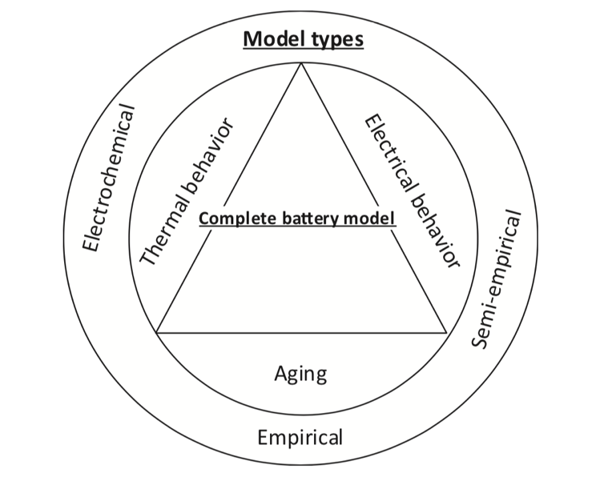

**Figure 3.** Battery modeling schemes

(iiii)

A block diagram of modeling system (Figure 4) is the first step for us to facilitate the state estimation and further develop our optimization model of battery aging. The next step of consummation the modeling is to incorporate our existing optimization program into a grid like system. By this way, we could mimic real world case more precisely and contribute to resolving the aging of battery while unconvoluting the complex distribution issue of power demands in each area.

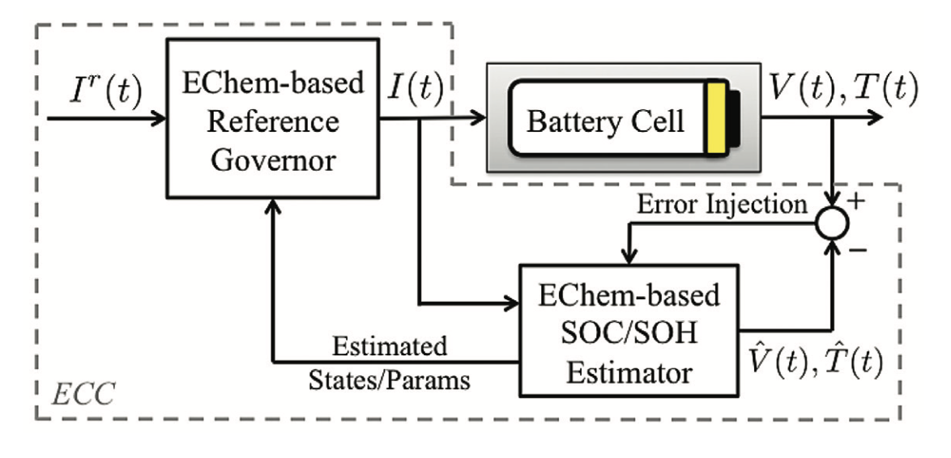

**Figure 4.** Block diagram of the ECC system comprised of a SOC/SOH estimator to determine the electrochemical states/parameters, and a reference governor to apply controlled charging/discharging.

## Focus of this Study

This study will focus on studying capacity fade in distributed rechargeable battery technologies by intimation the battery fleet with grid distribution system. We break down our focus into **two parts**: a) understanding parameters such as temperature, SOC, SOH, and DOD that contribute to battery aging and material degradation and b) designing a control framework to optimally distribute power to/from the battery fleet. With this two-prong focus we aim to automate battery monitoring, hopefully even when faced with unpredictable thermal and catalytic degradation.

1. Palacin, M. R.; de Guibert, A., Why do batteries fail? *Science* **2016,** *351* (6273), 7.

2. Vetter, J.; Novak, P.; Wagner, M. R.; Veit, C.; Moller, K. C.; Besenhard, J. O.; Winter, M.; Wohlfahrt-Mehrens, M.; Vogler, C.; Hammouche, A., Ageing mechanisms in lithium-ion batteries. *J. Power Sources* **2005,** *147* (1-2), 269-281.

3. Wang, J.; Liu, P.; Hicks-Garner, J.; Sherman, E.; Soukiazian, S.; Verbrugge, M.; Tataria, H.; Musser, J.; Finamore, P., Cycle-life model for graphite-LiFePO4 cells. *J. Power Sources* **2011,** *196* (8), 3942-3948.

4. Barre, A.; Deguilhem, B.; Grolleau, S.; Gerard, M.; Suard, F.; Riu, D., A review on lithium-ion battery ageing mechanisms and estimations for automotive applications. *J. Power Sources* **2013,** *241*, 680-689.

5. Kassem, M.; Bernard, J.; Revel, R.; Pélissier, S.; Duclaud, F.; Delacourt, C., Calendar aging of a graphite/LiFePO4 cell. *J. Power Sources* **2012,** *208*, 296-305.

6. Jaguemont, J.; Boulon, L.; Dube, Y., A comprehensive review of lithium-ion batteries used in hybrid and electric vehicles at cold temperatures. *Applied Energy* **2016,** *164*, 99-114.